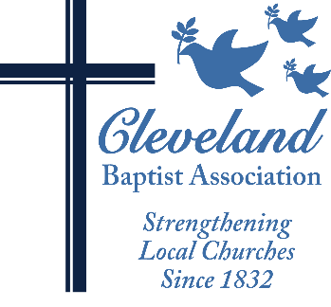**Cleveland Baptist Association**

**12200 Fairhill Rd. Ste C/440 Cleveland, Ohio 44120**

**Telephone: 216-325-7730 Website:** [**www.cbacleveland.org**](http://www.cbacleveland.org)

**Reverend Yvonne Carter, Executive Minister**

CLEVELAND BAPTIST ASSOCIATION

THEOLOGICAL EDUCATION SCHOLARSHIP FUND

APPLICATION PACKET

*Please read carefully and follow all instructions. Applications and all attachments are due by midnight on December 31, and should be mailed to Rev. Camille D. Brown, Scholarship Fund Administrator c/o the CBA office.*

______________________________________________________________________________

The following criteria have been established by the CBA Department of Ministry to govern awards from the Theological Education Scholarship Fund:

* Assistance is available for tuition, fees, and books related to a theological education program, graduate or post-graduate course and/or for tuition assistance for students applying to the Ohio Leadership Academy, a ministry of ABC/Ohio and CBA.
* Applicants must be members in good standing of a CBA mission-giving church and recommended by their pastor.
* The program or course for which assistance is requested must be offered by a seminary, Bible college, or school of religion accredited by The Higher Learning Commission of the North Central Association of Colleges and Schools and/or the Association of Theological Schools or by The Ohio Leadership Academy.
* The applicant must maintain a grade point average of 2.75 or better
* There must be a planned application of the learning for ministry.
* The program or course of study must be offered during the 2018-2019 Academic year.

If you meet the established criteria and are interested in applying, please complete the attached application form *legibly and in ink* and submit the application by the above deadline.

Please have your pastor sign the Pastoral Recommendation Form and submit it directly to the CBA Office by the application deadline.

All forms should be sent c/o Rev. Camille D. Brown, Fund Administrator.

Following the review of applications by the Department of Ministry, personal interviews may be scheduled. If you have any further questions, please contact Rev. Camille D. Brown at 216-325-7730.

**CLEVELAND BAPTIST ASSOCIATION** **THEOLOGICAL EDUCATION FUND**

**SCHOLARSHIP APPLICATION FORM**

_________________________________________________________________________________________

**Applicant’s Full Name and Title (Minister, Rev., Mr. Mrs. Ms):**

______________________________________________________________________ (H)___(W) ___(C)___

**Preferred Mailing Address (Home, Work, Church):**

_________________________________________________________________________________________

**City, State, Zip:**

_________________________________________________________________________________________

**E-Mail Address:**

­­­­­­­­­­­­­­­­­­­­­­­­­­­­­­­­­­­­­_________________________________________________________________________________________

**Home Phone (with area code):**

_________________________________________________________________________________________

**Work Phone (with area code):**

__________________________________________________________________________________________

**Name of Applicant’s CBA Church:**

***(Please check all the following that apply to you):***

_____Licensed

_____Ordained

_____Other (explain) _______________________________________________________________________

***Applying for a scholarship for:***

_____ Theological degree program

_____ Non-degree program

_____Ohio Leadership Academy 3-Year Program

________________________________________________________________________________________

**Name of Program or Course:**

_________________________ $_______________ (OR) $_________________

**Course Credit Hours/CEUs** **Cost of Course/Program Ohio Leadership Academy Tuition**

_____________________________________________________________________________

**Name and Address of School/Institution or Specialized Ministry Program**

_____________________________________________________________________________

**Dates of Program or Course:**

**Scholarship Application (Page Two)**

**Personal Goals and Aspirations**

Please describe your goals and aspirations in pursuing this program or taking this course. Please use reverse, or a separate sheet, if more space is needed.

**Current Ministry Involvement**

Please describe your current ministry involvement or duties in your local church.

**Current CBA Involvement/Knowledge**

Are you currently involved in any CBA Boards, Committees or Volunteer Service? Please describe.

Do you participate in the CBA Annual Meetings and/or Events? Please describe.

**Financial Need**

Please describe how the CBA Theological Scholarship will help you manage the costs associated with this course or program.

**Course/Program Description**

Please attach a brief description of the course or program for which support is being requested, along with evidence of enrollment and/or a transcript of previous work in program if applicable.

S

**Pastoral Recommendation**

Please provide the attached recommendation form to your pastor and ask him or her to return it directly to CBA.

***Thank you for your interest and your application!***

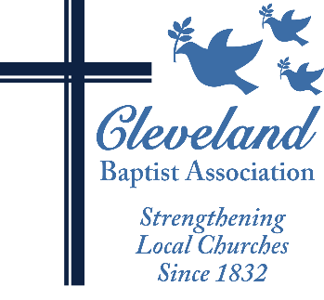**CBA THEOLOGICAL EDUCATION FUND**

**PASTOR’S RECOMMENDATION FORM**

Name of Applicant: ________________________________________________________________

Dear Pastor:

Each applicant for financial assistance from the CBA Theological Education Scholarship Fund must submit a Pastor’s Recommendation Form as part of the application process. Please take a few minutes and tell us about the above-named applicant.

Is the applicant an active member in good standing of your church and active in/attendee at CBA events? ______Yes ______ No

How is the applicant involved in ministry in and through your church?

How will the program or course of study for which assistance is requested enhance this person’s current ministry or potential for future ministry?

Has the church supported, or is it planning to support, the applicant with any financial assistance toward this program or course? ______Yes ______No

Please describe:

Do you recommend the applicant for a CBA Theological Fund scholarship award? ______Yes ______No

Name of Pastor: (Please Print) ________________________________________________________________

Signature: ___________________________________________________Date: ________________________

The deadline for the receipt of application material and recommendations is December 31st. Thank you for taking a few minutes to complete this form in support of this applicant. After completing this form, please mail it directly to: Rev. Camille D. Brown, Theological Education Scholarship Fund Administrator, Cleveland Baptist Association, 12200 Fairhill Ave. Room C/440 Cleveland, OH 44120.

***Thank You!***